Review: Chapter 1

**Written section:**

**1.2:** the three types of comments used in java are single line //, multiline comment /* */, and documentation comment /** */.

**1.3:** the 8 primitive types in java are int, double, char, boolean, float, long, byte, and short.

**1.4:** the difference between * and *= operators are if you use * you are just multiplying to variable together like z*t if z=2 and t =3 then the answer is 6, but if you use the operator =* and you do z and t again like z*=t you will change the value of z instead of just outputting a number so it would be like z = z*t so you would still output 6 but now 6 would be the value for z.

**1.6:** the 3 types of loops in java are for loop which is mostly used if you want to loop through something a fixed number of times, then a while loop which is repeated if the conditions are meet and if not, it stops repeating, and then a do while loop which is similar to the while loop but it will execute a block of code once and then check to see if a condition is meet and if it is then it will keep repeating.

**1.9** method overloading is when a class has other methods that have the same name but have different argument list.

**In Theory:**

**1.12:** first you would execute true && false which would end up being false since in the “and” boolean operation it has to be the same or it is false. But after it is false || true which in the “or” boolean operation if one is true then it is true.

**1.14:** that output that would come out from this line of codes would be 0, what ever input is put for variable x is what will be outputted from the print.

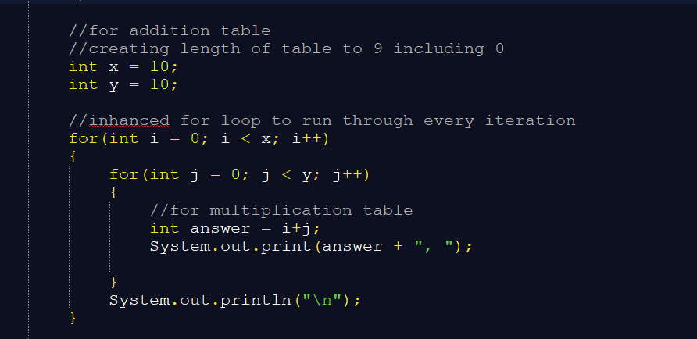**Programming:**

**1.16:** first I did the addition table for the chart 0-9 my code was

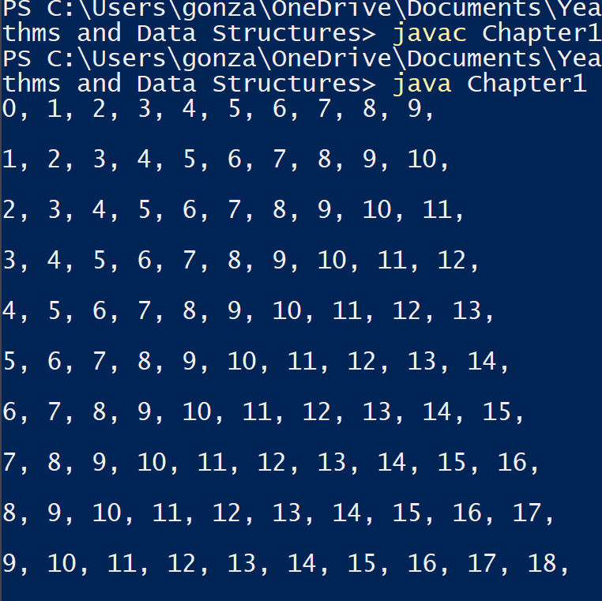

My result for the code

Worked well expected the outcomes.

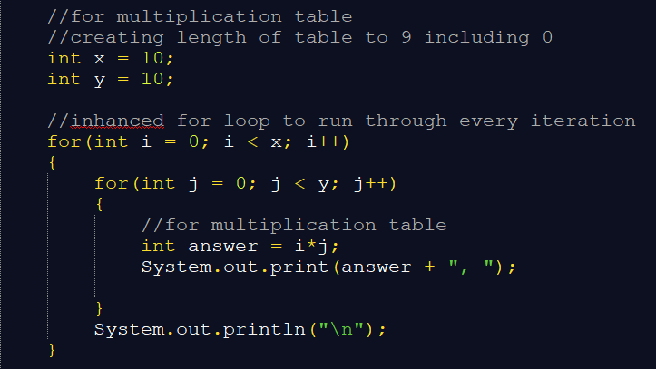

Then I did Multiplication

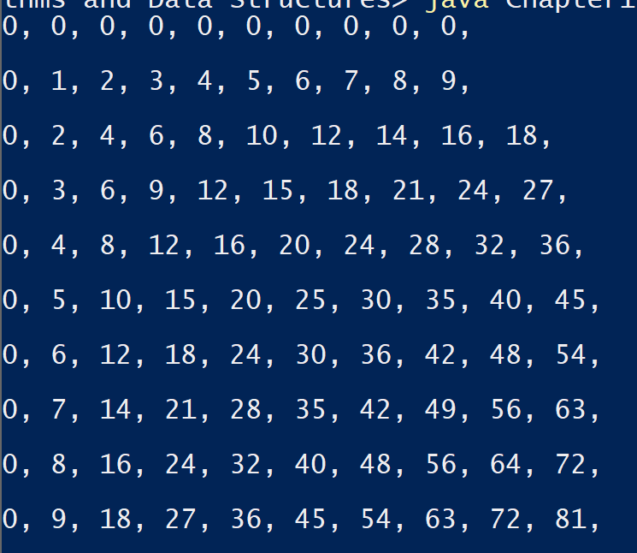Outcome is also what I expected.

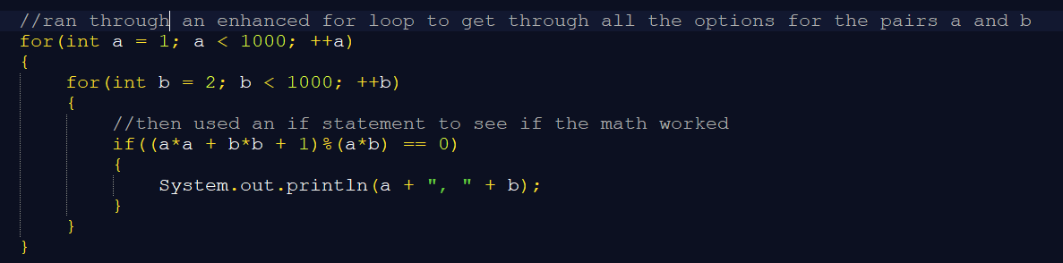**1.19:**

Checked the code with modulus to see if it was an int because if the reminder was zero then it is and int and it prints

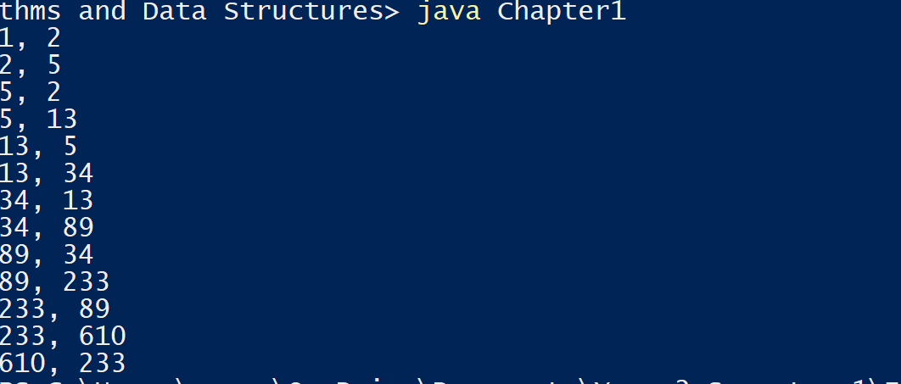

Here are the outcomes